


CITY OF MIAMI BEACH RENEWS OAK VIEW GROUP'S MANAGEMENT CONTRACT FOR MIAMI BEACH CONVENTION CENTER
Global Venue Leader to Continue Oversight of Award-Winning Convention Center, Driving Innovation, Sustainability, and Economic Growth in South Florida

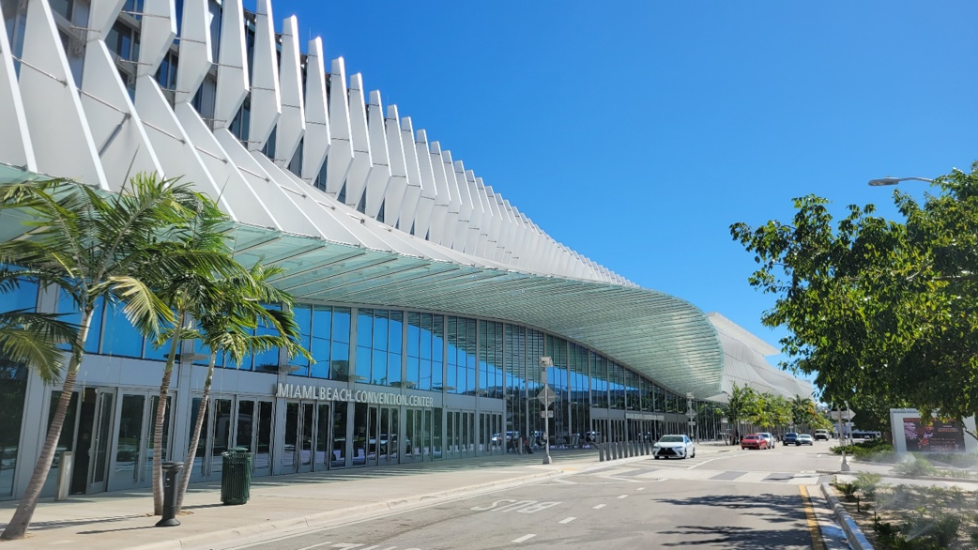

MIAMI BEACH, FL (April 23, 2025) – The City of Miami Beach has renewed its contract with Oak View Group (OVG), a global leader in live experience venue development, management, premium hospitality, and integrated venue services, to continue managing the Miami Beach Convention Center (MBCC) — South Florida’s largest and most prominent convention venue.

OVG has managed the MBCC for the past 12 years (formerly as Spectra until 2022), consistently elevating the venue’s profile as a premier global destination for meetings, incentives, conferences, exhibitions, and social events. In recognition of its innovation, service excellence, and technological capabilities, the MBCC was named “Best Convention Center in the U.S.” by Skift Meetings in 2024.

“The Miami Beach Convention Center plays a vital role in driving our tourism economy and is recognized globally as a premier destination for major events,” said Miami Beach Mayor Steven Meiner. “Oak View Group’s professionalism and operational excellence give us great confidence in the future of this iconic city asset.”

OVG was a key partner in the MBCC’s $640 million renovation and expansion, which transformed the venue into a state-of-the-art facility featuring a 60,000-square-foot Grand Ballroom, four junior ballrooms, 500,000 square feet of exhibition space, 84 breakout rooms, a dramatic Grand Lobby and light-filled pre-function areas, and 800 rooftop parking spaces. The convention center also boasts 2,100 miles of IT and communication cabling and $10.2 million in public art installations.
Complementing the venue are six acres of green space at Pride Park and three acres at Collins Canal Park, both offering versatile event settings. Two new venues enhance the MBCC campus: Venu, an upscale private event and meeting space, and Rum Room, a 1920s-inspired restaurant featuring a tapas-style menu and exclusive South Florida rums. Looking ahead, the Grand Hyatt Miami Beach Convention Center Hotel, scheduled to open in 2027, will connect to MBCC via skybridge and usher in a new era for the enhanced property.

OVG has also been recognized for its commitment to sustainability, earning the Silver Certificate for Sustainability & Social Impact from the Events Industry Council in 2024. Under the renewed agreement, OVG will further enhance its green initiatives, implement advanced sustainability practices, conduct a facility condition assessment, and strengthen cybersecurity measures.

“This renewed partnership underscores our ongoing commitment to the City of
Miami Beach,” said Greg O’Dell, President, Venue Management, Oak View Group.
“We are proud to deliver exceptional customer experiences with a focus on innovation, sustainability, and continued facility improvements. We look forward to building on the MBCC’s success and deepening our community impact.”

The MBCC has hosted some of the world’s most prestigious events, including Art Basel Miami Beach, the Super Bowl LIV Fan Experience, the Miami International Boat Show, and the Adobe MAX Creativity Conference.

“This renewal reflects the dedication of our incredible teams, our partnership with the City of Miami Beach, and the ongoing collaboration with the Greater Miami Convention & Visitors Bureau,” said Freddie Peterson, General Manager of the MBCC. “We remain committed to delivering exceptional events and unforgettable experiences while supporting the local economy.”

In addition to the MBCC, Oak View Group manages several properties across Florida including the Palm Beach County Convention Center, Donald L. Tucker Civic Center at Florida State University, Addition Financial Arena at the University of Central Florida and the Seminole Theatre in Homestead, FL.

# # #

About Oak View Group
Oak View Group (OVG) is the global leader in live experience venue development, management, premium hospitality services, and 360-degree solutions for a collection of world-class owned venues and a client roster of arenas, stadiums, convention centers, music festivals, performing arts centers, and cultural institutions. Founded by Tim Leiweke and Irving Azoff in 2015, OVG is the leading developer of major new venues either open or under development across four continents. Visit OakViewGroup.com, and follow OVG on Facebook, Instagram, LinkedIn, and X.

CONTACTS:
Ariane Hiltebrand, Miami Beach Convention Center, ariane.hiltebrand@oakviewgroup.com
Teri Washington, Oak View Group, twashington@oakviewgroup.com

